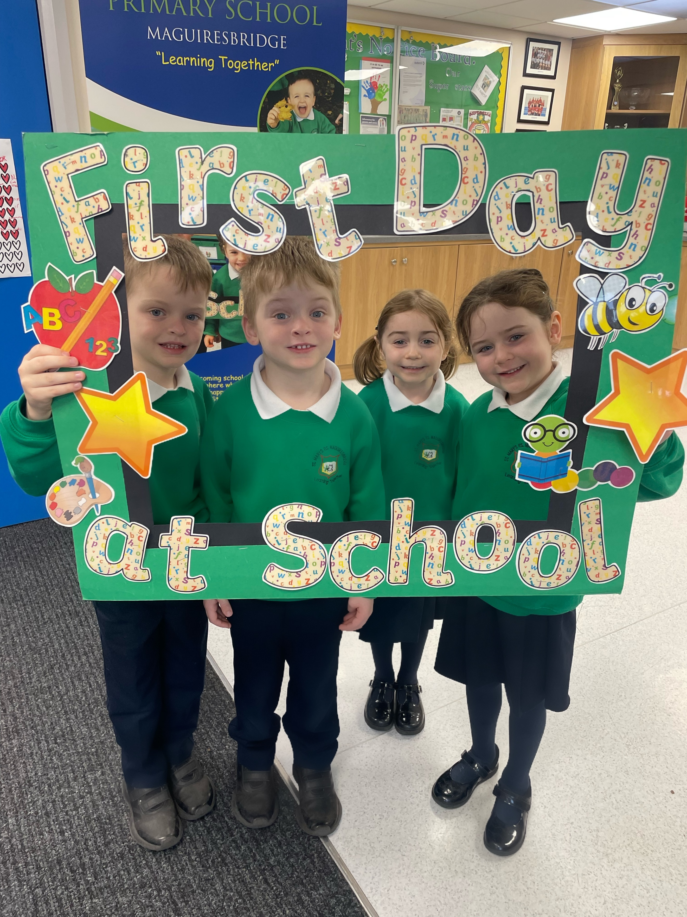
WELCOME

TO ST MARY'S PS

Dear Parents,
Principal:  Mr John Prunty  B.Ed, M.Ed, PQH (NI)  Tel: 028 677 21413  Fax: 028 677 23868 | 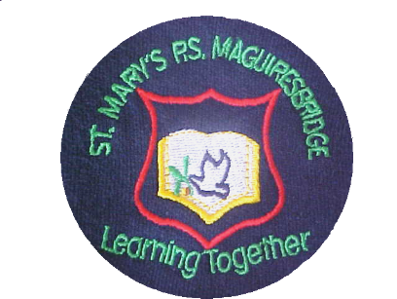 | 9 Lisnagole Road,  Coolcrannel  Maguiresbridge  Co Fermanagh  N Ireland  BT94 4RG

It gives me great pleasure to welcome you and your child to St. Mary's P.S Maguiresbridge to learn, enjoy and participate fully in the next stage of your child’s life, seven years of enjoyable and rewarding learning at Primary School. We're very conscious of the responsibility with which you are entrusting us; namely the educating of your child. Our principal aim is to help all children to not only attain a high level in the basic skills but to encourage them to blossom as individuals and to use to the fullest the talents that God has given them.

We are committed towards achieving the highest standards for your child and working with you closely to achieve this. We are conscious of the fact that you have been your child’s first teachers and the continued importance of your role in your child's education is key to success. An open and trusting relationship must exist between the home and the school to achieve these high ideals and so we always encourage an ‘open door’ policy where you should feel comfortable to chat to the class teacher or arrange a meeting with the class teacher at any time of the year discuss any concerns you may have.

We look forward to seeing you in school and if there are any questions or queries you have please do not hesitate to contact me.

Yours sincerely,

John Prunty
(Principal)

website: www.stmarysmaguiresbridge.com Email: jprunty429@c2kni.net

ST MARY’S PRIMARY SCHOOL
SCHOOL INFORMATION

9 Lisnagole Road Enrolment No: 134
Maguiresbridge Admissions No: 19
Enniskillen
BT94 4RG
Tel No: 028 67721413
Fax No: 028 6772 3868 PRINCIPAL: Mr John Prunty
E-mail: jprunty429@c2kni.net
CHAIR OF BOARD OF GOVERNORS: Mr. Frank Hughes
RESPECTIVE FUNCTIONS OF THE BOARD OF GOVERNORS AND PRINCIPAL IN RELATION TO ADMISSIONS.
The Board of Governors have delegated to an Admissions Sub-Committee the task of selecting pupils for admission. The Sub-Committee consists of the Principal and three other Governors.

The following criteria will be applied in the order set down (1-7) by the Board of Governors of St Mary's Primary School in selecting children for admission to Year 1 in September. Children normally resident in Northern Ireland will be considered before all others.

Priority will be given at all times to pupils regarded by the Board of Governors, on the basis of supporting evidence by parents and/or statutory agencies, as having special circumstances (medical, social factors).

Children who are not of compulsory school age will only be selected for admission after all children of compulsory school age have been allocated a place.

ADMISSIONS CRITERIA –YEAR 1/RECEPTION
During the admissions procedure when applying the criteria punctual applications will be considered before late applications are considered. The application procedure opens on 9 January 2024 at 12noon (GMT) and an application submitted by the closing date of 26 January 2024 at 12noon (GMT) will be treated as a punctual application. An application received after 12noon (GMT) on 26 January 2024 and up to 4 pm on 31 January 2024 will be treated as a late application, this is also the last date and time for processing a change of preference in exceptional circumstances. After 4 pm on 31 January 2024 no applications will be processed until after the close of procedure on 25 April 2024.

Priority will be given to children who will have attained compulsory school age at the time of their proposed admission, including those children whose parents deferred their admission to primary school in September 2023 as defined by the new School Age (NI) Act (both groups to be treated equally).

- Children of compulsory school age who have brothers/sisters (half-brothers/sisters) presently enrolled in the school.
- Children of compulsory school age whose families have traditionally attended the school (i.e parent/guardian/brother/sister/half/foster/adopted brother/sister)
- Children of compulsory school age who normally reside in the Parish of Aghalurcher.
- Children of compulsory age from other areas.
- Children aged 4 but who have not attained the lower limit of compulsory school age and who normally reside in the Parish of Aghalurcher.
- Other children aged 4 who have not attained the lower limit of compulsory school age.

The school will continue to admit children not of compulsory school age as above, unless the Department of Education determines that such children will be zero-rated for funding purposes.

In the event of over-subscription in any one of the criteria, taken in order, final selection will be on the basis of the closeness of the home to the school as measured by shortest walking distance using Google Maps.

YEAR 1 ADMISSIONS – AFTER THE BEGINNING OF THE SCHOOL YEAR

If a place(s) become available after 1 September 2023 and there are more applicants than places then selection of pupils will be made on the application of the Year 1 Admissions Criteria to those pupils seeking admission at the time the place(s) become available.

DUTY TO VERIFY

The Board of Governors reserves the right to require such supplementary evidence as it may determine to support or verify information on any application.

If the requested evidence is not provided to the Board of Governors by the deadline given, this will result in the withdrawal of an offer of a place. Similarly, if information is supplied which appears to be false or misleading in any material way, the offer of a place will be withdrawn.

WAITING LIST POLICY

The school does not operate a Waiting List Policy.

ADMISSIONS CRITERIA – YEARS 2-7

Pupils will be considered for enrolment provided that:

- the school would not exceed its enrolment number; and
- in the opinion of the Board of Governors their admission would not prejudice the efficient use of the school’s resources. If, at the time of the consideration of the application, there are more eligible applicants than places available then the Admissions Criteria for Year 1 of pupils of compulsory school age will be applied.

Applications and Admissions to Primary 1 including Reception
Year | Total Applications | Total Admissions
2021/2022 | 21 | 21
2022/2023 | 25 | 25
2023/2024 | 27 | 23

Figures above include P1 and Reception applications and admissions
ST MARY’S PRIMARY SCHOOL
STAFF

TEACHING STAFF
Principal (P.7 teacher) Mr. John Prunty
Principal Release Mrs. Chloe Lecky
P.1 Mrs Helen O’Hanlon
P.2 teacher Mrs Bronagh Mohan
P.3 teacher Mrs Áine King
P.4 teacher Miss Lorraine Gordon
P.5teacher Miss Laura Cadden
P.6 teacher Miss Eimer Maguire
Special Needs Ms Lorraine Gordon
Child Protection Officer Mr. John Prunty
Deputy C.P. Officer Mrs Áine King

ANCILLARY STAFF

School Secretary Mrs Rita Collins
Classroom Assist. Mrs Veronica Mc Nally
Mrs Siobhan McManus
Mrs Diane Cathcart
Mrs Kate Beggan
Mrs Olga Curry
Ms Teresa Mc Dermott
Mrs Arlene Lavery
Mrs Rose Wray
Mrs Claire O’Reilly
Mrs Anne Kearns
Caretaker and school
Crossing Patrol Mrs Margaret Kelly
School Chaplain Canon Jimmy Mc Phillips



ST MARY’S PRIMARY SCHOOL
BOARD OF MANAGEMENT

CHAIRMAN OF GOVERNORS: Mr Frank Hughes

PRINCIPAL Mr. John Prunty

NUMBER ON ROLL 1 September 2023 157

EXPECTED NUMBER ON ROLL 1 September 2024 159

THE BOARD OF GOVERNORS

Nominated by the Trustees
Mr Frank Hughes
Mrs Bryony May
Mrs Rosemary Markey
Mrs Joanne Gartlan
Education Authority Representative
Mrs Margaret O’Reilly
Mrs Ann Potter
D.E. Representative
TBC
Elected by the Parents
TBC
Elected by the Teaching Staff
Mrs Helen O Hanlon

Principal (Non-Voting)
Mr. John Prunty


GENERAL INFORMATION

St. Mary's Primary School is a Maintained School, which admits boys and girls aged from 4 to 11. It is set in its own pleasant grounds on the outskirts of Maguiresbridge. The school seeks to promote a friendly caring atmosphere and parents are always welcome to visit the school.

SCHOOL HOURS

The school day begins at 9.10am. Children should not arrive at school before 8.45am unless they are attending the Breakfast Club which operates from 8am at a cost of £2 per day.

The lunch break is from 12.30 to 1.15pm.

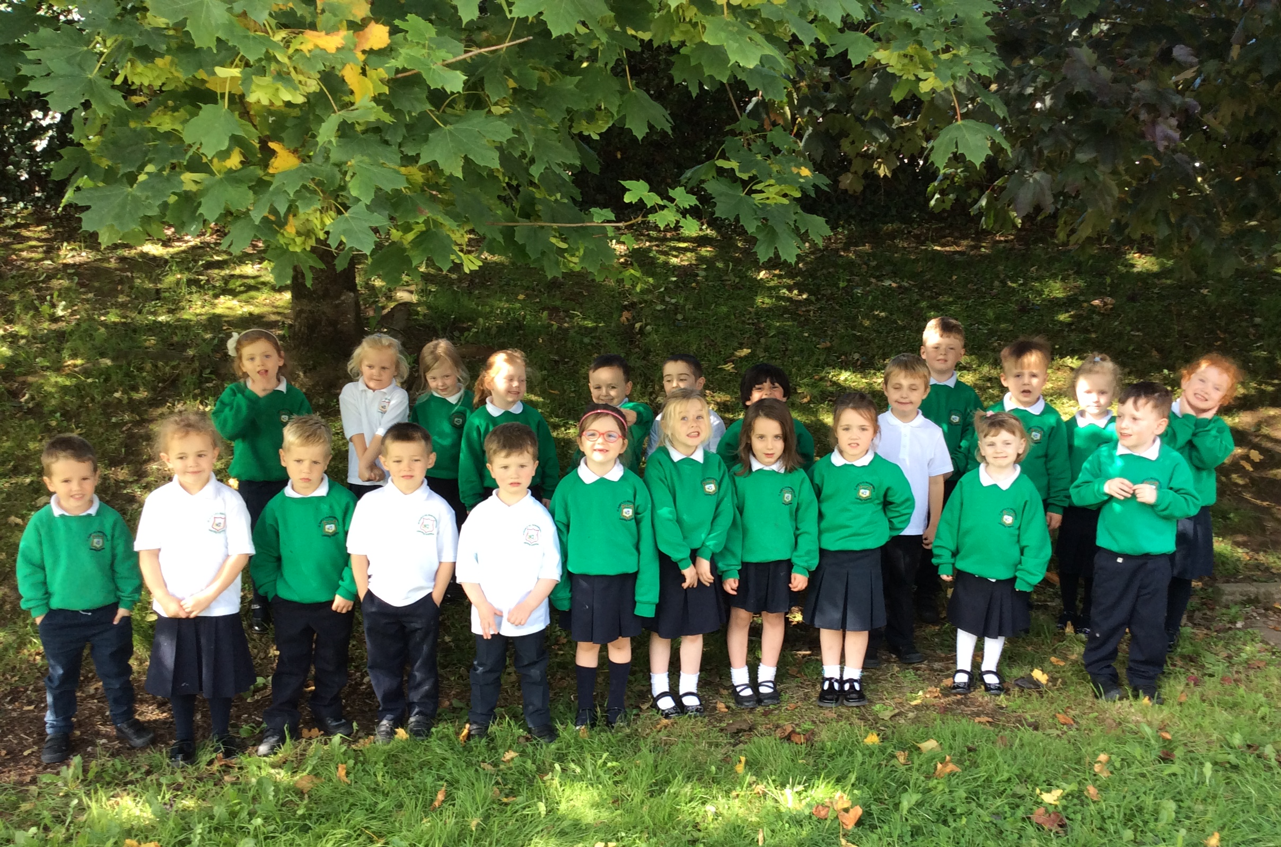
All the children have a supervised playtime for 15 minutes in the middle of the morning.

The P.1 and P.2 classes finish their school day at 2.00pm and the P.3 - P.7 classes finish their school day at 3.00pm.

After school provision from 2pm-3pm is available at a cost of £2 per day.

In our school we aim to develop a range of skills and core values and attributes through our ethos and the delivery of the Northern Ireland Curriculum.


Primary school is divided into three stages

Foundation Stage P1–P2 - Ages 4–6
Key Stage 1 P3–P4 - Ages 6–8
Key Stage 2 P5–P7 - Ages 8–11

At all three Key Stages, children build and improve their personal, social, intellectual, physical and emotional skills. In their earliest school years, your child will take part in well-planned, hands-on and challenging play that makes the most of their interests and natural curiosity.
As they move from Foundation Stage to Key Stage 2, they will explore and develop the main skills they will need throughout their life, such as:
- controlling their feelings and emotions;
- being able to work with others;
- talking and listening;
- reading and writing;
- maths;
- problem-solving; and
- how to use ICT.
Every day they will take part in worthwhile, challenging and enjoyable activities that give them chances to practise these skills. The children through the teaching and learning delivered in St Mary’s will develop as whole individuals with core values and moral character.
CURRICULUM DELIVERY IN ST MARY’S PS
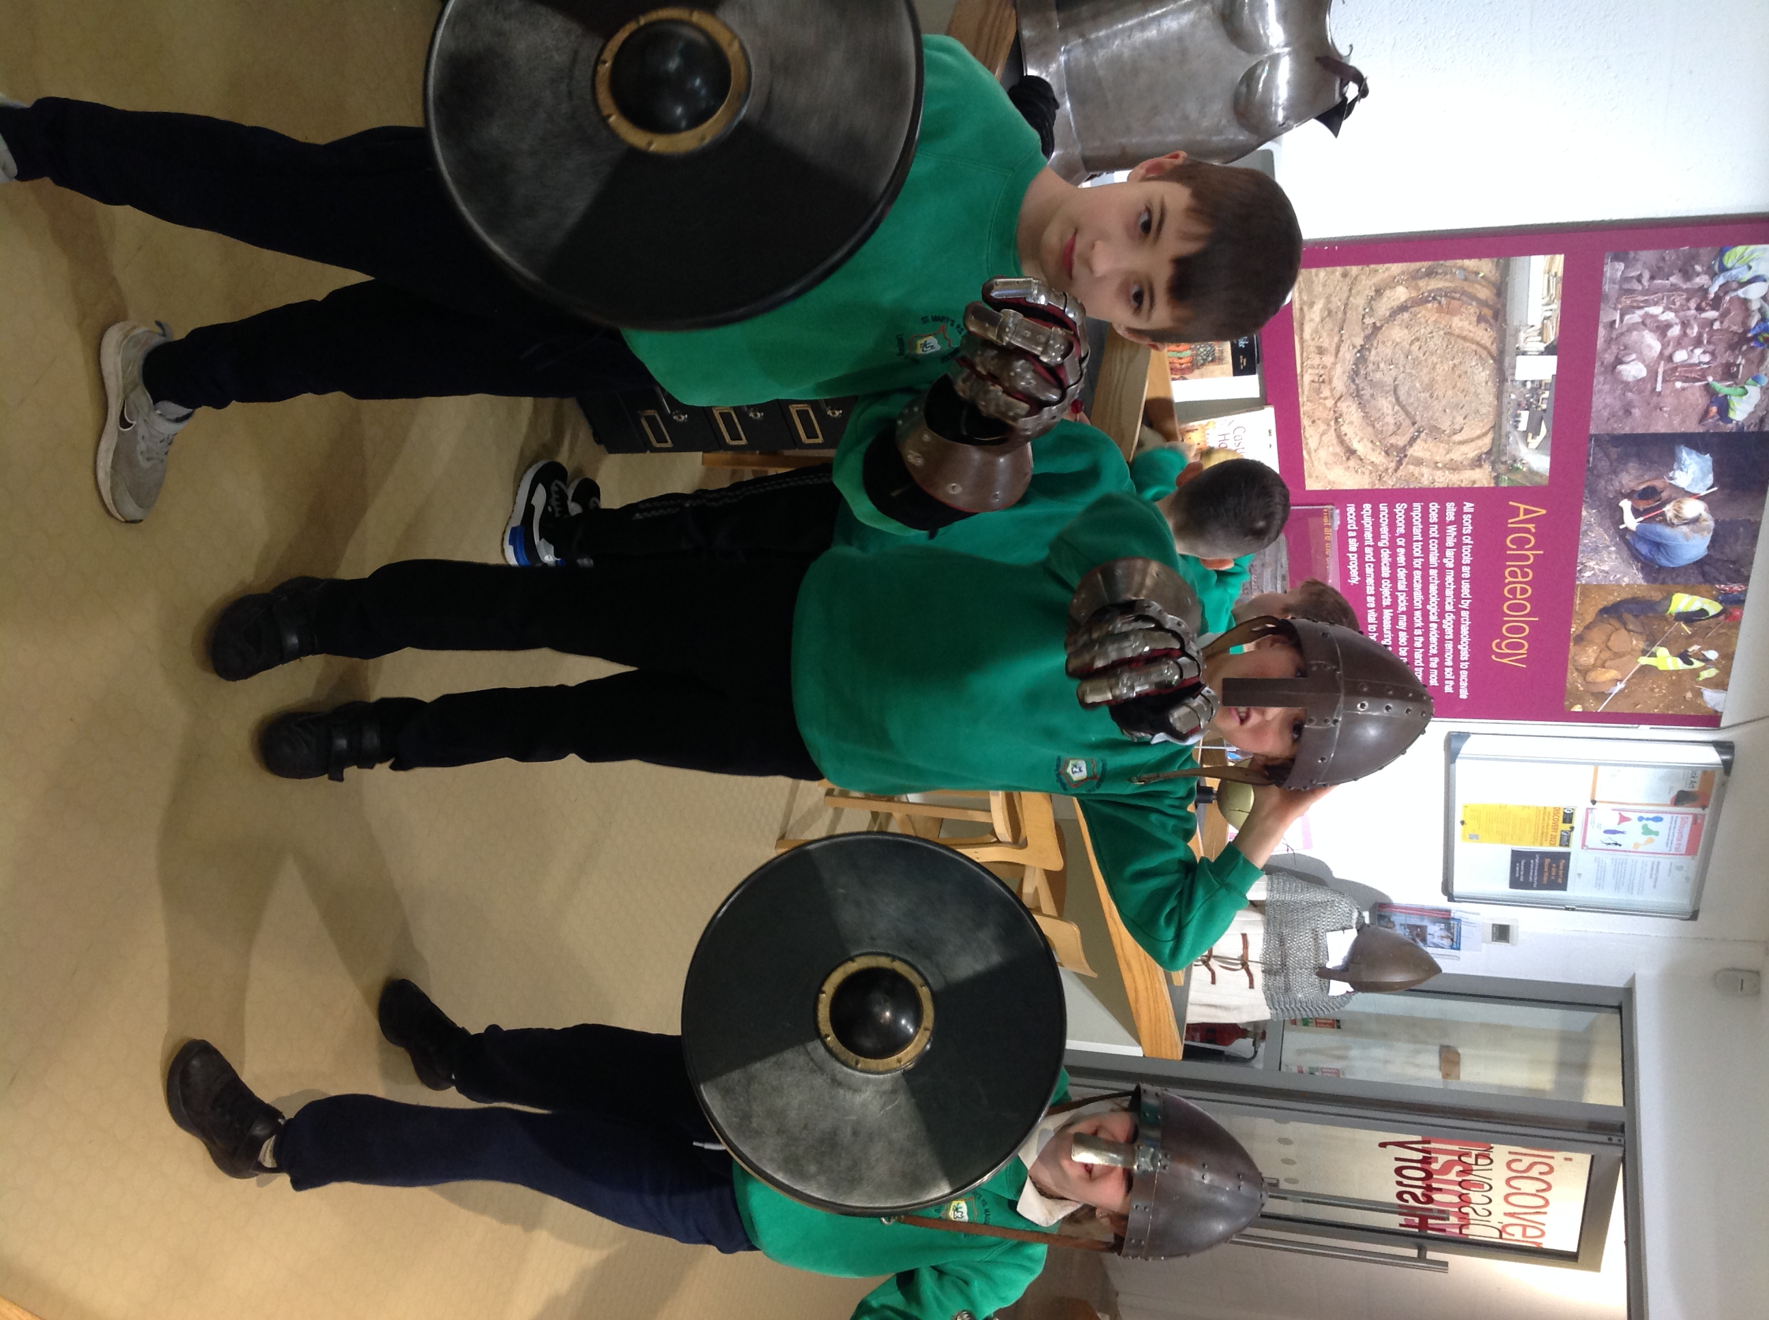

When we speak of curriculum in our Catholic school we are talking about the learning experiences that are present for each child, those planned by the staff and those embedded from our school ethos and environment. Since Christ is the foundation of the whole educational enterprise in a Catholic school, all our curriculum will attempt to reflect Christ's message. When planning our curriculum we take into account the uniqueness of each child and his/her individual needs. We develop attitudes and values based firmly on the Gospel message. Our aim is to offer each child a broadly based and appropriately balanced curriculum in line with the new Northern Ireland Revised Curriculum.
This involves Seven Areas of Learning:
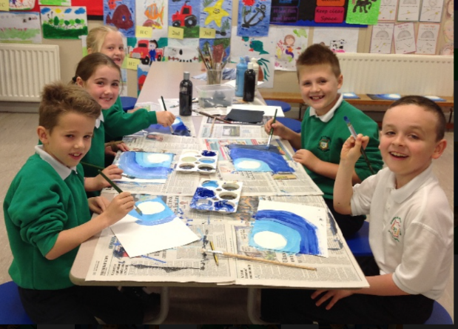
The Arts
Language and Literacy
Mathematics and Numeracy
Personal Development and Mutual Understanding
The World Around Us
Physical Education
Religious Education
and Cross Curriculum Themes:
Communication
Using Mathematics
Using ICT

THE R.E. PROGRAMME WE OFFER OUR CHILDREN

Our R.E. Programme based on the Grow in Love programme goes beyond the requirements of the core R.E. syllabus agreed by the main churches. It prepares each child for participation in the liturgy and sacraments of the Catholic Church. Religious Education is not confined to the timetabled programme within the school but pervades the whole life of our school.
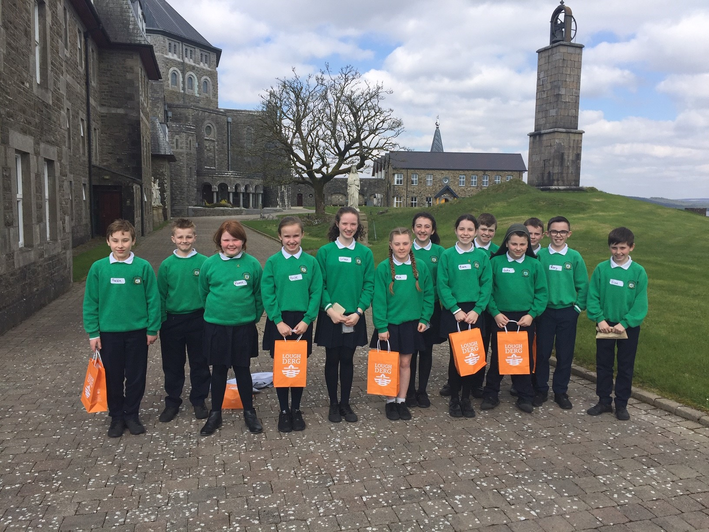
LINKS WITH OTHER AGENCIES

We see the school as a vital part of our parish and take every opportunity to contribute to the life of that parish. In order to do this we liaise closely with our local priest and church organisations. Canon Jimmy visits our school regularly to get to know the staff and the children in school.

Parents can choose to withdraw their child/ren from Religious Education and/or Collective Worship at any time in St. Mary’s P.S. Parents should contact the school principal to make specific arrangements for this or contact the school principal via email jprunty429@c2kni.net

We have established close links with our local secondary schools in order to ease each child's transition to second level education. Visits for the P.7 children are arranged to their new schools in the summer term.

We co-operate with and fully support the work carried out by the local Health Authority personnel and when necessary, we seek the help and advice of other statutory agencies. Visitors like the school nurse. EA Learning Support and Educational Psychologist call at the school in order to cater for the needs of your child.

SPECIAL EDUCATION PROVISION

Care is taken at all times to match the curricular provision for all children to their particular stage of development and to take account of any particular difficulties or special talents which they show. Where provision beyond what can be given by the class teacher is required, every attempt will be made to provide this by the other staff in the school. In particular, the teacher with responsibility for Special Educational Needs, Miss Gordon will use her time to help those children diagnosed as being in greatest need. If necessary the specialist services of the Board’s Special Education Section will be used.

HOMEWORK

The school believes in the values of homework and, in particular, homework that will consolidate work previously done in class. Parents are encouraged to help the child/ren with their homework (not to tell them but to help them arrive at the answer through discussion) and this has the added advantage of keeping parents informed of their child's progress.
To ensure regularity it will be school policy that homework will be set each night from Monday to Thursday.
“It is our belief that homework is relevant to the child’s age, ability and interests, contributes to the development of independent learning skills and fosters initiative.
We believe that such homework provides the opportunity for practice and consolidation of work done in school. It reinforces and extends skills and understanding particularly in the areas of literacy and numeracy.
We believe that the provision of homework encourages partnership with our parents/guardians and we see it as essential that parents/guardians and teachers co-operate to promote the social, emotional, moral and intellectual development of the child.” (Homework Policy 2023 – available from the school office.)

OUT OF SCHOOL ACTIVITIES

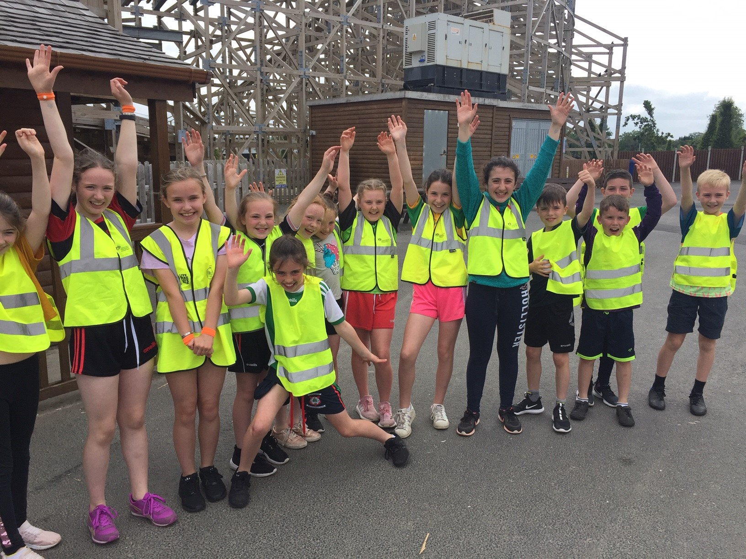
Many activities take place out of normal school hours and these include football, netball, homework club and cycling proficiency. The variety and details of these will change from time to time, depending on the expertise and interest of individual members of staff and the availability of the activities generally. Every term trips are organised for each class to places of interest generally connected with their World Around Us Topic of the time. The continuation of these activities will, following the introduction of statutory requirements under the Education Reform Order, depend on the voluntary contributions of parents towards the costs.

EXTRA CURRICULAR ACTIVITIES

There is a culture existing in the school of teacher giving of their time to help pupils achieve; whether it be in netball, with teachers giving up their break-time to practise netball skills in the run up to a tournament, or in art and craft where teachers would help children who are struggling at a particular piece of work.

Cycling proficiency, football and netball coaching are organised as after school activities. All members of teaching staff help out with the extra curricular activities such as Christmas Nativity, First Holy Communion and Confirmation.

P.E KIT

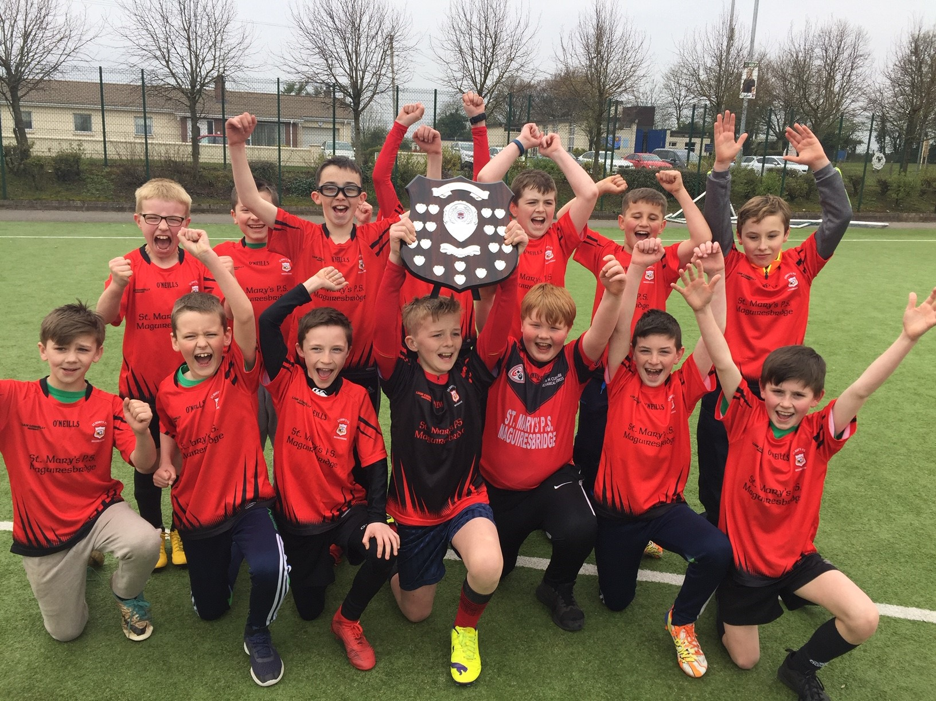
Children are expected to be provided with suitable clothing for P.E. and games. All children should have a pair of shorts at school for P.E. lessons, as well as a school PE T-shirt. Older children who go swimming should provide swimming costume, towel and a swimming hat if appropriate, on days when swimming should take place. Older children who do football or netball should have suitable clothing and footwear for these activities on days when the lessons take place.

NAMES ON CLOTHING

It is hugely important that all children’s uniform is clearly marked or labelled.

HOME/SCHOOL CONTACT

Parental contacts with the school are actively encouraged by the teaching staff. The parent's support is essential in working with the school for the child's benefit. St. Mary’ attempts to foster parental relationships in various ways such as invitations to concerts and plays, sports days, meetings and other events as well as informal contacts at the beginning and end of the school day. More formal contact is made in the annual progress interviews with the class teacher. Parents may contact the Principal about any matter at any time when the school is open. However, this should, as far as possible, be out of teaching time or during his office days to keep class disruption to a minimum.

ASSESSMENT REPORTING AND RECORD KEEPING IN OUR SCHOOL
An assessment of children’s work is an integral part of our school. The main purposes of assessment are to:

- Establish through a variety of means what each child is able to do.

- Assist the teacher in planning appropriate tasks for each child.

As part of this assessment pupils are tested on a regular basis with the results formally recorded by the teacher and reported to parents. The records of each child's attainment and work samples are passed on to each successive teacher. We invite parents to read these records and see the samples of their child's work at the annual parent teacher meeting.

TRANSFER ARRANGEMENTS:

At the end of P.7 (Key Stage 2) when children are transferring to second level education our school will follow the special arrangements as laid down by the Education Authority (EA). Parents will have the opportunity to meet the Principal and class teacher for advice and discussion. Copies of the transfer arrangements will be distributed to the parents of the P.7 children.

CLASS ORGANISATION:

There are seven class units in our school, each grouped according to the age of the children. Since it is our school’s policy to do the best for each child, teachers will organise their classes in a variety of ways in order to cater for individual needs of the children in their care.

ADMISSION ARRANGEMENTS

The current policy is to admit children into the P.1 class on the first day of the Autumn term who have reached compulsory school age, i.e. those children whose 4th birthday falls on or before 1st July.

If places are available there is a Reception Class for those children who are 4 before the end of October.

Parents considering sending their children to this school are invited to make a prior visit, to see the school in action and to talk to the Principal and teachers. The admission arrangements as set out in the EA booklet on Primary Education will be used. Application forms are available from the school, Board offices or board website.


ATTENDANCE

All children should attend school for the 190 days which the law requires, unless they are ill. If children have to miss school for illness or any other reason, then parents should send into school a note explaining the absence for our records. The attendance rate for 2022/2023 was 95%.

SCHOOL UNIFORM

Primary 1 - 7 will wear Navy trousers/skirt, White Polo Shirt (with school logo) and round neck sweater (with school logo) all year round. The girls will have the option to wear a green and white chequered dress from the first day back after Easter until the 30th of September.

The school compulsory P.E Kit for all children from P.1 – P.7 will be navy shorts or navy tracksuit bottoms to go along with the green logoed t shirt.

All children will wear black shoes or completely black coloured footwear all year round. Exceptions to this will be during periods of snow fall when any boots will be acceptable.

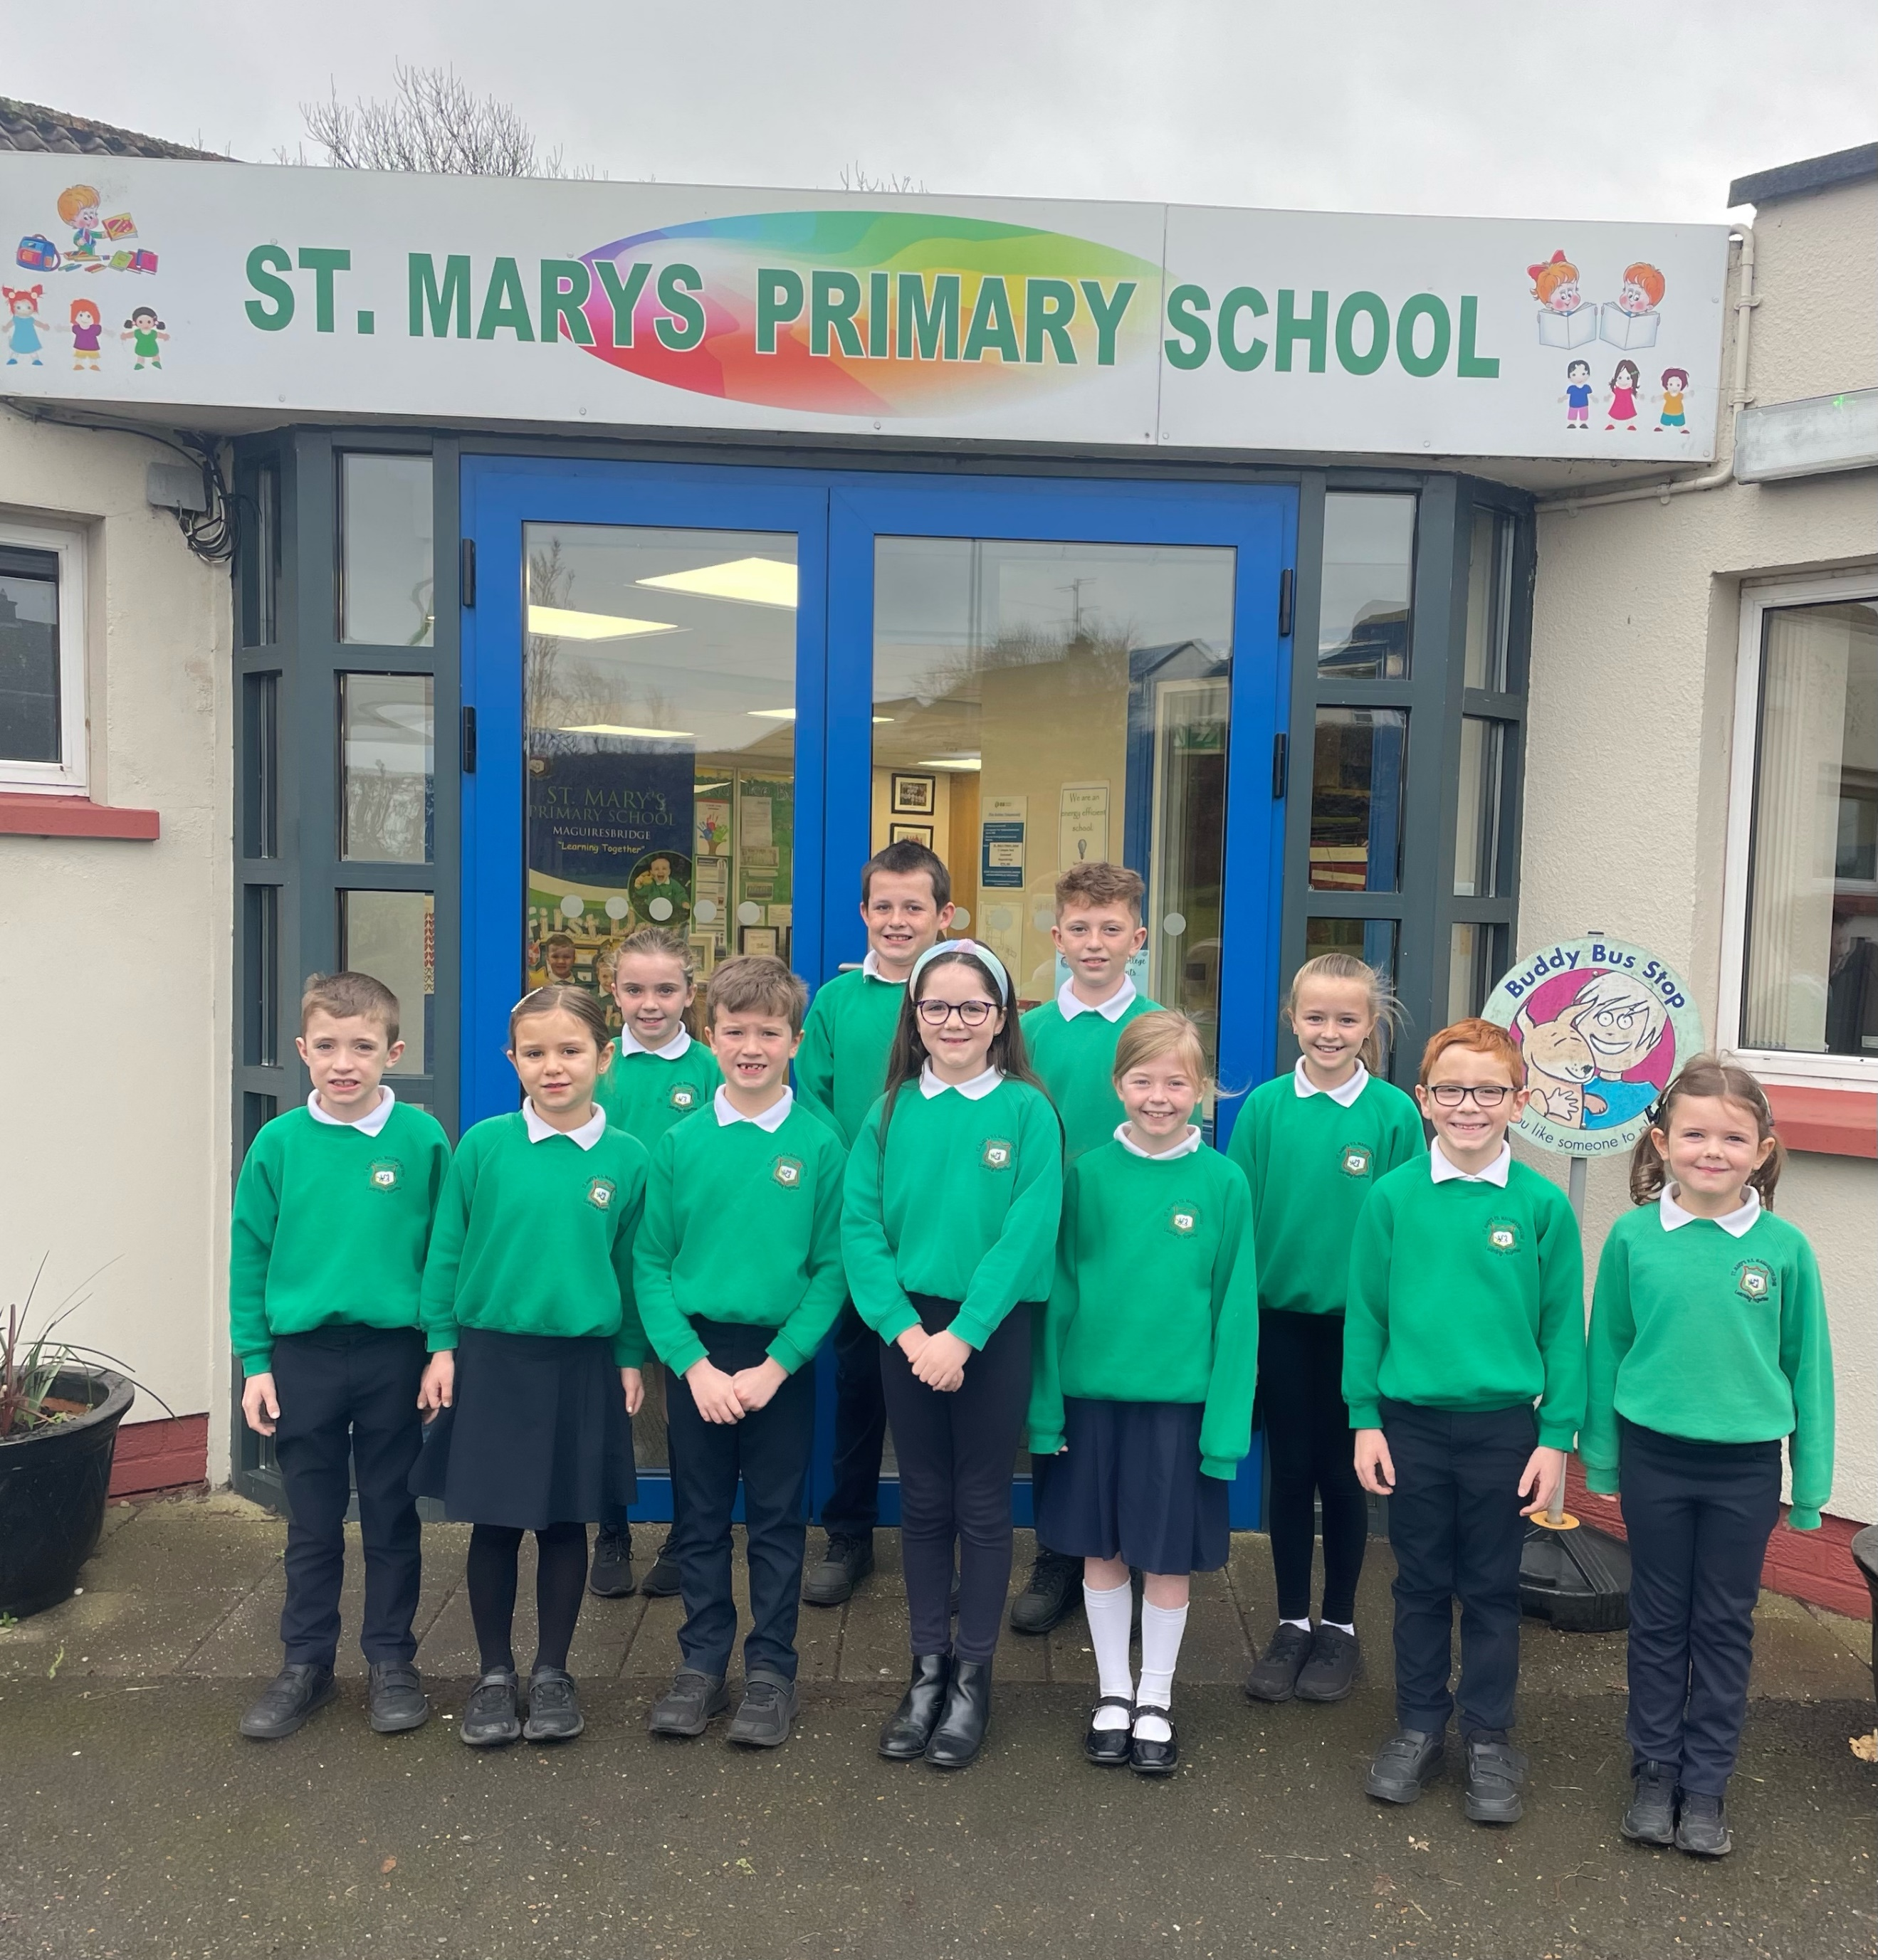

POLICIES
All policies are available on request from the school office or a selection of policies are available online on the school website.

We would draw your attention I particular to the Child Protection and Safeguarding Policy.

https://www.stmarysmaguiresbridge.com/our-school/policies/



